LXFML Tags

Copyright © 2005-2009 LEGO System A/S

1 Introduction 3
2 Concepts 3
2.1 Models 3
2.2 Brick 3
2.3 Part 3
2.4 Flex 3
2.5 Decoration 3
2.6 Meta 3
2.7 RefID 3
2.8 Transformation 3
2.9 Camera 3
2.10 RigidSystem 3
2.11 Rigid 4
2.12 Joints 4
2.13 Groups 4
2.14 Building instructions 5
2.14.1 Step 5
3 LXFML Element Diagram 6
4 LXFML Tag Reference 7
4.1 Common fields 7
4.2 <LXFML> 7
4.3 <Meta> 7
4.4 <Cameras> 7
4.4.1 <Camera> 7
4.5 <Bricks> 7
4.5.1 <Brick> 8
4.5.2 <Part> 8
4.5.3 <Bone> 8
4.6 <RigidSystems> 8
4.6.1 <RigidSystem> 8
4.6.2 <Rigid> 8
4.6.3 <Joint> 9
4.6.4 <RigidRef> 9
4.7 <GroupSystems> 9
4.7.1 <GroupSystem> 9
4.7.2 <Group> 9
4.8 <BuildingInstructions> 10
4.8.1 <BuildingInstruction> 10
4.8.2 <Camera> 10
4.8.3 <Step> 10
4.8.4 <PartRef> 10

Introduction
This document gives a conceptual overview and provides a tag reference for the LEGO eXchange Format Markup Language (LXFML) version 5. Further details of the format are described in the schema file “lxfmlschema.xsd”.

Concepts

Models
The term model refers to a LEGO model built from LEGO bricks. The geometry of the bricks and the complete model they compose are not part of the model description. Models are stored in LXFML.

Brick
The term brick refers to a LEGO construction-element abstraction. A brick can be made of one or more parts. A brick could describe any physical or virtual object ever created by the LEGO Company, but for several reasons we restrict the term brick to the physical or logical form of those objects.

Part
The physical equivalent of a Part is a solid piece of plastic. A brick can consist of one or more parts. A Part in turn is made up of bones; all part has at least one bone.

Flex
The term flex refers to a soft LEGO part. Flex parts are described using a bone structure. The only difference between flex and non-flex parts is that flex parts have more than one bone.

Surface
A Surface is a sub-part of a Part’s geometry which can be used for color change or decoration. All parts have at least one surface.

Decoration
A Decoration is a picture that is drawn on a surface on a single Part.

Meta
The LXFML format supports a variety of non-model description information. Users may save their own information in a Meta element. A Meta element consists of two distinct types of information, of which none, one, or both types may make up the element:
- A plain text string
- A list of key-value pairs

LEGO has predefined some Meta elements in the schema file, which can be used by users or applications as long as they adhere to the syntax defined in the schema. Users are encouraged to prefix their Meta element names to avoid future clashes with LEGO defined names.

RefID
Several objects in an LXFML file may be used by other objects, in order to describe such a link, or reference, all objects that can be referenced have a unique refID value that can be used to point to the object. All refID’s for a given type must be unique across the entire file regardless of scope.

Transformation
A transformation is used to place objects in the world. It is defined by a transformation matrix. Objects can be placed relative to other objects, in such a case the world transformation is calculated by concatenating the transformations.

Camera
A Camera is used to describe points of view; as such a Camera has a position in the world, a view direction and field of view.

RigidSystem
In LXFML a RigidSystem is intended to be a connected structure that is equivalent to a model that you can hold in your hand. A RigidSystem element is made up of one or more Rigid elements. All RigidSystems are placed in the world coordinate system and define a local coordinate system for rigids.

Rigid
A Rigid (structure) contains a list of Bones; it defines a local coordinate system for these Bones.

Joints
A connection between two Rigid elements inside the same RigidSystem element is described by a Joint element. This jointed structure is not limited to describe a hierarchy but may also form a looping graph.
Joints are described by a position and two perpendicular axes. Currently two types of joints are defined: the ball joint and the hinge joint, the following is the description of what the axes mean for these joints.
- Ball joint
  - The ‘a’ axis is the primary axis, protruding out and away from the foundation of the joint
  - The ‘z’ axis is the secondary axis
  - The ‘t’ vector is the translation vector.
  - The third axis can be calculated by crossing the ‘a’ and ‘z’ axes
  - The axes are only interesting when rotational constraints are used
- Hinge joint
  - The ‘a’ axis describe the rotation axis
  - The ‘z’ axis describes a zero axis from where rotational constraints can be calculated
  - The ‘t’ vector is the translation vector.

It is possible to convert this jointed structure into a hierarchical structure by doing the following described by pseudo code, be aware that loops in the structure are broken:

List handledRidigs.
Function BuildHierarchyHelper(current Ridig)
If(current Ridig not handled)
Mark current Ridig as handled
For(all r Ridigs connected to current Ridig)
Make r Ridig a child of current
BuildHierarchyHelper(r Ridig)
End
End
End

Function BuildHierarchy()
Clear handledRidigs
For(all ridigs)
BuildHierarchyHelper(current)
End
End

Groups

A group is a list of references to parts. Groups are introduced to make it possible for the user define human understandable grouping within a model, which makes some model editing easier.

Building instructions
LXFML allow for the description of building instructions (BI). Building instructions are made up of a sequence of steps.

Step

A step in a building instruction introduces a Part into the BI world, however if the Part is part of a brick contains more than one Part, all parts for the brick are introduces into the BI world when the first of its parts are introduced. Therefore all parts for a brick must always be within the same step and be followed by each other without parts for other bricks between them. This means that even though the building instruction is defined using parts, it is actually visualized using bricks.

In the future when explosions are introduced Steps may refer to the same Part several times, once every time a Part is exploded.

Steps may contain other steps. The motivation behind is to emulate the vignettes known from paper building instructions. An example of steps in steps is shown in the following BI:

Step A
Part p1
Step B
Step C
Part p2
Part p3
Part p4
Step D
Part p5

When viewing the above BI as a time line the following Parts are to be shown:

Time 1 Time 2 Time 3 Time 4
p1 p2,p3 p1,p2,p3,p4 p1,p2,p3,p4,p5

LXFML Element Diagram
Below is a diagram showing the different elements in LXFML and their relationships. The arrows indicate which elements can have which elements as children / parents. The arrow describes a parent to child relationship.

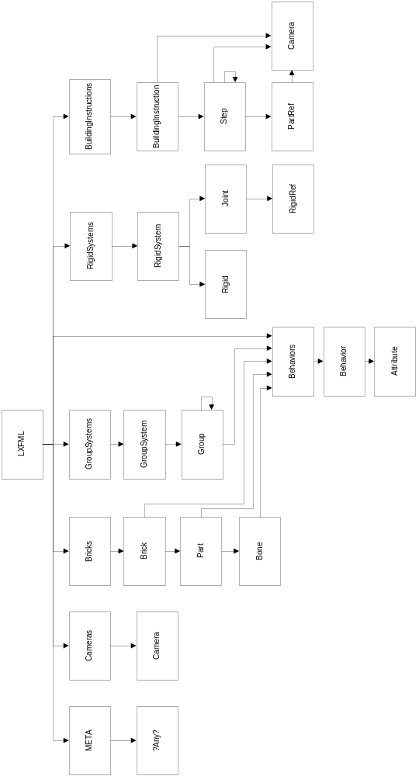

LXFML Tag Reference

Common fields

Transformations

The transformation field present in the Camera, Bone, Rigid are comma-separated lists of floating point values representing a 3x4 transformation matrix. The list is converted to a matrix by reading 3 values at a time as 1 row in the matrix.

Common tags

<Behavior>

The Behavior element is a container element for the Attribute element. Currently used for describing LEGO Universe (game world) behaviors.

Fields:
name Name for the behavior

<Attribute>

A key and value element.

Fields:
key Key for the attribute
value Value for the attribute

<LXFML>

The element container for the entire LXFML file.

Fields:
versionMajor Major version number for the LXFML file.
versionMinor Minor version number for the LXFML file.
name Name for the content of the LXFML file.

<Meta>

The element container for any kind meta data elements.

Fields:
None.

<Cameras>

The element container for camera elements.

Fields:
None.

<Camera>

Describes camera positions used for storing the camera position to view the model and steps in the building instruction.

Fields:
refID Unique reference identifier for the element.
fieldOfView The cameras field of view in degrees.
distance Distance (negative z-axis) to the rotation point for the camera in camera space.
transformation Places the camera in world space.

<Behaviors>

Container element for Behavior element which are defined for the entire model.

<Bricks>

The element container for Brick elements.

Fields:
cameraRef Reference to camera

<Brick>

The element container Part and Behavior elements. A brick element describes a physical brick which is composed of one or more parts.

Fields:
refID Unique reference identifier for the element.
designID Unique design ID for the brick.
itemNos Unqiue item Nos for the brick. Used in physical brick production. If the brick contains a decoration, the item Nos is extended with a ‘#’ followed by a number unique, which together with item Nos before the ‘#’ unique indentifies the decorated brick.

<Part>

A part is a physical piece of plastic which can have materials and be decorated. Can also contain Behavior elements.

Fields:
refID Unique reference identifier for the element.
designID Unique design ID for the part. For Brick elements with only one part this is equal to the Brick elements designID.
materials Comma separated list of material identifiers. The value 0 denotes a decoration.
decoration Comma separated list of decoration identifiers.

<Bone>

Denotes a (bone) part of a Part element. Can also contain Behavior elements.

Fields:
refID Unique reference identifier for the element.
transformation Places the bone in world space.

<RigidSystems>

The element container for RigidSystem elements.

<RigidSystem>

The element container for Rigid elements. A rigid system is a collection of connected rigids.

<Rigid>

A rigid is a collection of bones (from parts) which together form a rigid structure.

Fields:
refID Unique reference identifier for the element.
transformation Transformation matrix for the element.
boneRefs Comma separated list of bone reference identifier which the rigid is composed of.

<Joint>

The element container for RigidRef elements. Denotes a connection between exactly two rigids.

Fields:
type A string denoting the type of joint. Supported types are “hinge” and “ball”.

<RigidRef>

Rigid ID reference element.

Fields:
rigidRef Rigid identifier reference.

a A comma separated vector which depends on the joint type.
Ball joint: The primary axis, protruding out and away from the foundation of the joint.
Hinge joint: The rotation axis.

z A comma separated translation vector which depends on the
joint type.
Ball joint: The secondary axis.
Hinge joint: The zero axis from where rotational constraints can be calculated.

t Comma separated translation vector.

<GroupSystems>

The element container for GroupSystem elements.

Fields:
None.

<GroupSystem>

The element container for Group elements.

Fields:
None.

<Group>

A Group defines a logical grouping for Parts. Can also contain Behavior elements

Fields:
transformation Transformation matrix for the element.
pivot User defined rotation point for the group.
partRefs Comma separated list of Part reference identifiers for the group.

<BuildingInstructions>

The element container for BuildingInstruction elements.

Fields:
None.

<BuildingInstruction>

The element container for Camera and Step elements.

Fields:
name Unique name for the building instruction.

<Camera>

Denotes the camera to use at the current point in the building instruction.

Fields:
cameraRef Camera reference identifier

<Step>

The element container for Camera, Step (recursive) and PartRef elements. Substep in the building instruction is defined by a Step element contained within another Step element. See concept description.

Fields:
name Unique name for the step.

<PartRef>

Part reference element.

Fields:
partRef Part reference identifier.

